Day 9 : Laravel DB Configuration

Submitted by : Nisha Jagtap  
Internship : Webteam pvt ltd  
  
  
**Updated .env file**  
  
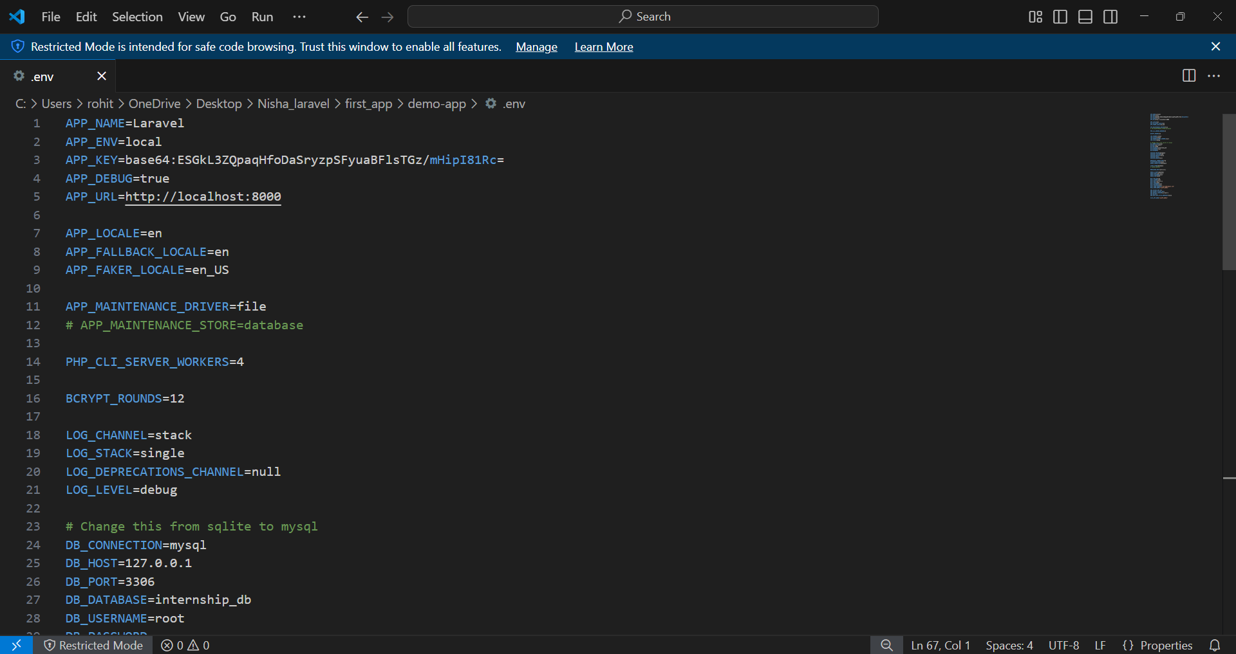

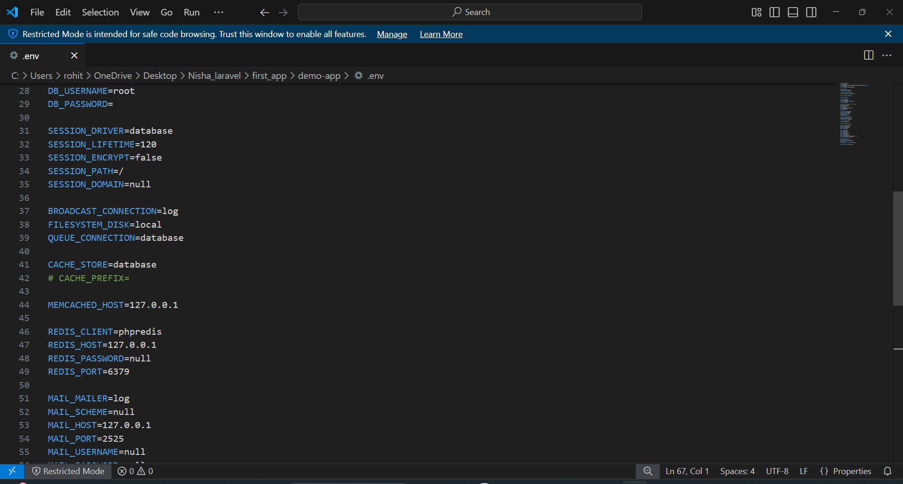

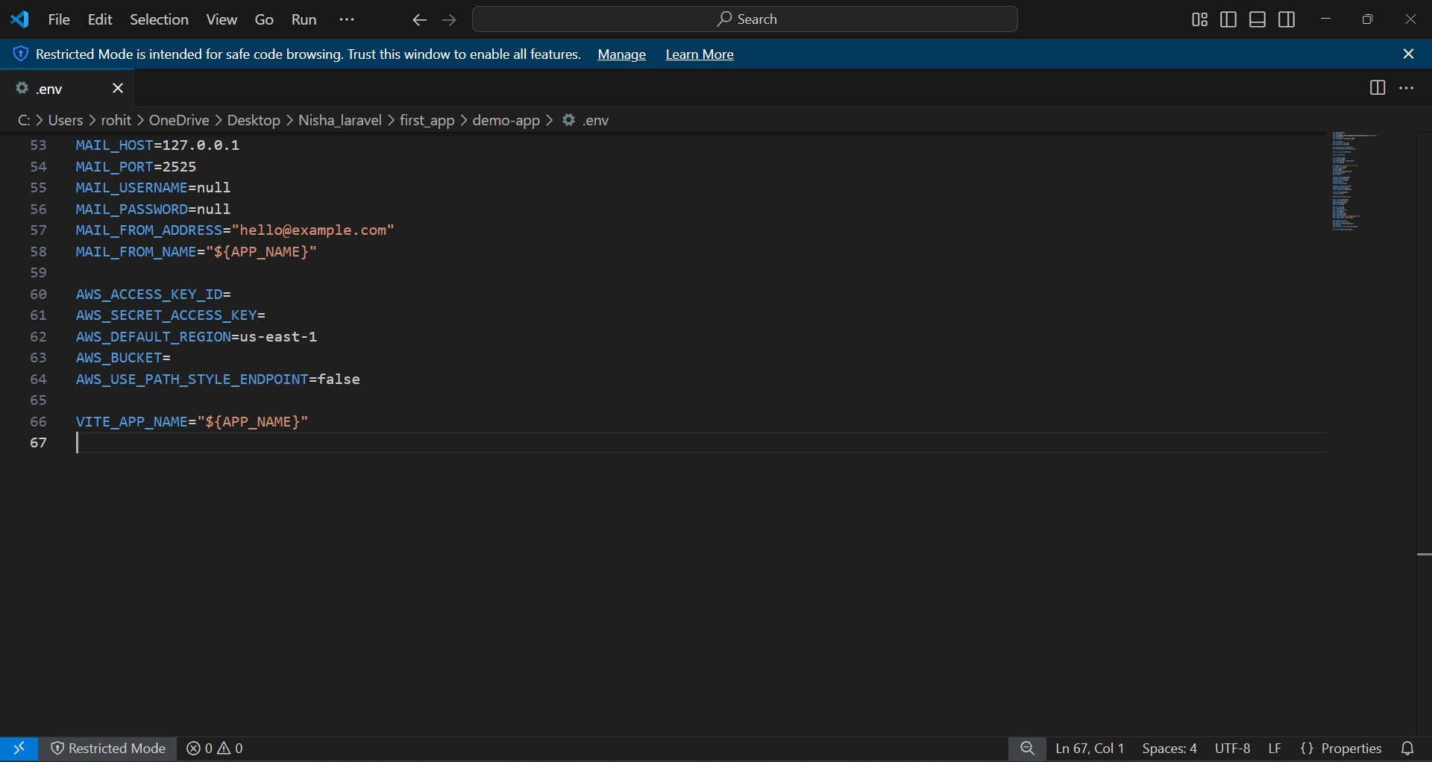

**Screenshot of successful database connection and migration**

